Blog Wallaby Versatility

Wallaby is a tremendously versatile meat and we produce a wide range of cuts.

Topside and porterhouse for pan frying.

They are portioned in 40 gm weight ranges (larger are 160-200 gm each), fully trimmed and given 3 weeks pack age before they leave us.

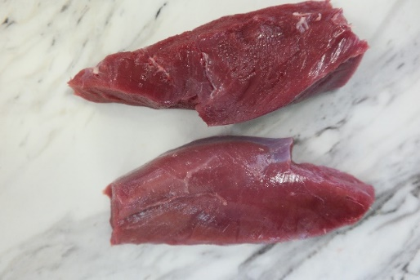

The fine texture of wallaby makes these cuts very forgiving.

Shanks, are for doing just what you would with a lamb shank, only better.

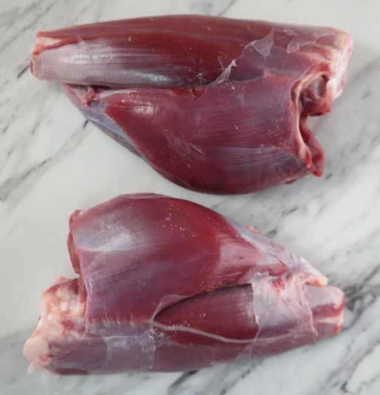

Wings and rib racks let you get really creative

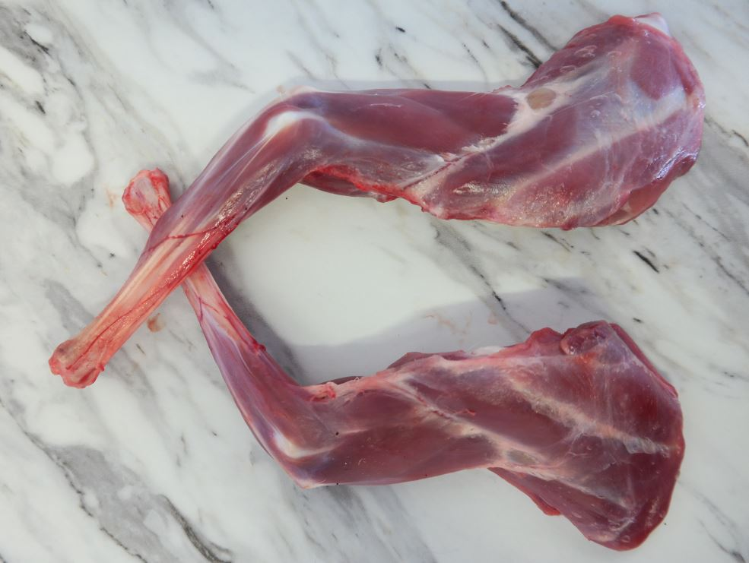

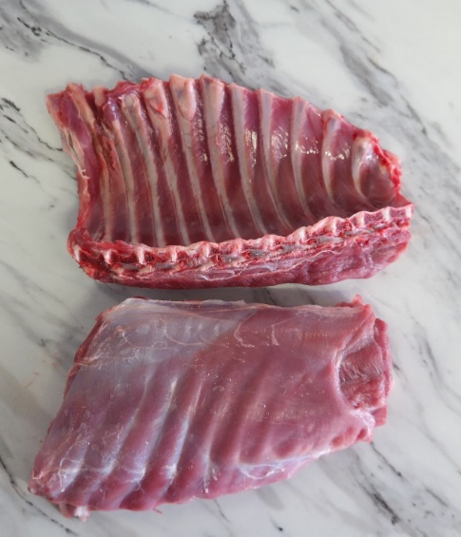

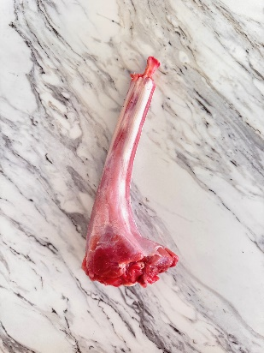Tails are fantastic for consumes.

Tasmanian and delivered direct to you.