Not just wallaby

At Lenah we also do Tasmanian roo (better than any of that stuff from South Australia!) and the best of all, wild harvested Tasmanian fallow deer venison (possibly the best venison in the Southern Hemisphere !!!!!)

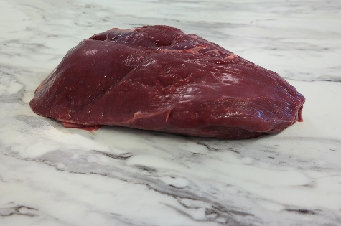

*Venison roast*

We do a full cut range of both and special things like venison ribs and necks.

And then there are hare and wild rabbit

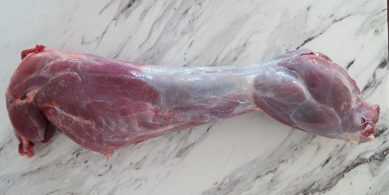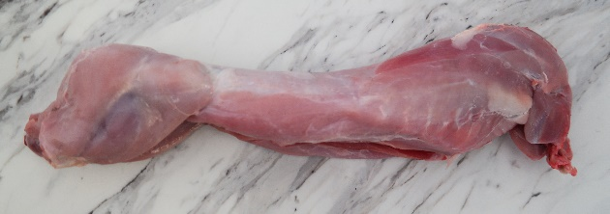

*Hare Rabbit*

All are taken direct from the wild by our professional harvesters and processed to our high standards.

All Tasmanian and delivered direct to you from us in Launceston