A recent experience with a customer has reminded me that not everyone understands wild animals have quite different meat quality parameters to domestic animals and not everyone understands how vac-packaging works.

Tip 1. Sheep and cattle have been bred over thousands of years to yield high fat levels, partially because fat tastes good but more so because once you start selecting the biggest and fastest maturing animals you also get increased levels of fat.

Fat comes in three types:

1. **Subcutaneous** fats are the thick hard layers beneath the skin.
2. **Intermuscular** fats are layers between muscle groups.
3. **Intramuscular** fats woven amongst the muscle fibres and sheaths this is called marbling.

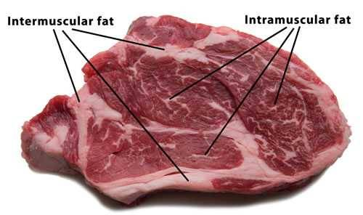

It’s the fat in beef and lamb which allows you to cook the be-jesus out of it and maybe still have something moderately eatable. This isn’t because fat has high levels of moisture; fat is only about 10% water where-as tissue is 75%. It’s because the fat layers, of intramuscular fat in particular, form a layer of insulation around the muscle fibres and prevent moisture loss.

Game meats like venison and wallaby have almost no intramuscular fat and very low levels of intermuscular fats (and then only in really good seasons).

Tip 2. The process of vacuum-packing was invented to extend shelf life in meat. By removing all the air from a bag and then sealing it we deprive the bacteria in the meat (everything, meat included, has some bacteria) from oxygen and therefore reduce their capacity to grow. Bacterial growth is what causes food spoilage. However vacuum-packing can also improve meat eating quality by allowing time for natural enzymic activity to partially break down meat fibres. This is known as “pack ageing”. Well-handled meat can ‘age’ in vack-packs for 10-12 weeks and still be safe to eat.

Game meats in particular benefit from pack aging.

Tip 3. When meat is packed in a vac-bag it’s a bright red colour. This is because many of the red blood cells in the meat still have oxygen attached to their haemoglobin enzymes. Any piece of meat, unless it’s been soaked in a sanitising solution will have some bacteria on it (the trick of hygienic meat production is to keep these levels as low as possible). After the bag is sealed and all the air removed these bacteria will seek whatever oxygen they can to keep alive, this includes the stuff still attached to red blood cells. Once oxygen is removed from a haemoglobin enzyme it changes to a dark red colour. Take the meat out of the bag and expose it to air and the haemoglobin enzymes will bind to oxygen out of the air and go back to brighter colour.

Tip 4: Remember the bacteria in lesson no 3 which used the oxygen on the haemoglobin after the vac-pack was sealed? Well, they do what bacteria do and create a bit of smell (but given there’s only a very small amount of oxygen available, it’s only a small smell). So, when you open a bag of vac-packed meat you release that smell. It’s the same as opening red wine, don’t stick your nose straight into it, allow vac-packed meat to breathe, then smell it.

Tip 5: Now, remember that fat from lesson 1 that helps hold moisture in the meat when it’s cooked? Well, it does the same thing in vacuum packed meat. Vac-packed game meat will weep more moisture than vac-packed beef or lamb because there is no fat to prevent moisture loss from the tissue. So, a vac-pack of game meat at say 3 weeks will probably have more weep than a pack of beef at 10 weeks.

Game meat benefits greatly from vac-pack aging because it helps break down fibres and improves eating quality. BUT it will also result in a pack smell which you must let dissipate before smelling the product. It will also lead to more weep than in domestic meats which have been in a bag for the same period of time. The weep doesn’t mean it’s been in the bag for too long, like it might with beef, it actually indicates the eating quality will be enhanced.

These notes apply to venison more so than wallaby. Our wallaby has a much finer texture than venison, but even so, vac-pack age enhances it’s eating quality.

Enjoy.